MULTI-DISEASE PREDICTION USING MACHINE LEARNING
(An Intelligent Health Assistant for Diabetes, Heart, Liver and Kidney Risk)
Scope and Limitations
Department of Computer Science and Engineering, TKR College of Engineering and Technology (Autonomous)
Batch A3 (CSE-A) · Academic year [ACADEMIC YEAR]
Table 1: Project team
S.No. | Student name | Roll number
1 | AJMEERA HARINI | 23K91A0507
2 | BANDI LIKITHA | 23K91A0526
3 | CHINTHAKINDI SWATHI | 23K91A0555
4 | BADROJU SRI HANSIKA | 23K91A0524

Project guide: B. SRUTHI, Faculty Project Guide, Department of CSE
Chapter and section numbers quoted in the text (for example Section 6.6 or Chapter 8) refer to the full project report, 17.Final Document. Figures and tables in this document are numbered from 1.

1. SCOPE
In scope. The system covers the following, all of which are implemented and were run:
• Generation of four synthetic clinical data sets (diabetes, heart, liver, kidney; 2,000 rows each) with the column names of the public benchmark data.
• Training and comparison of Logistic Regression, a Decision Tree, a Random Forest and an RBF SVM for each disease on standardised inputs, with accuracy, precision, recall and F1 reported and the best model by F1 saved.
• A Flask application (original) and a FastAPI service with seven routes that load the saved models and return a risk class and a confidence for one record.
• A React web interface: landing page, overview, one prediction form per disease with real-record samples and input validation, a model-comparison page, a dataset page and an about page; dark and light themes; phone-width layout.
• Supplementary measurements for the documentation: ROC-AUC, confusion matrices, cross-validation, ten random splits, threshold and sensitivity sweeps, permutation importance, a real-data check and API tests.
Out of scope. The following were deliberately not built:
• Diagnosis, treatment advice or any clinical decision; the application is a demonstration of a screening pipeline.
• Other diseases and free-text or image input; every condition takes a fixed list of numeric laboratory and clinical fields.
• Scoring one record against all four diseases at once: each disease has its own form and its own required fields.
• Per-prediction explanations, healthcare recommendations, feature selection, missing-value imputation and outlier handling.
• User accounts, a database, storage of patient records, an audit log, deployment in a hospital or any integration with health-record systems.
• Hyper-parameter search, probability calibration and nested cross-validation.

2. ASSUMPTIONS
• The relationships between inputs and risk in the synthetic data are a stand-in for real clinical relationships; the risk rules were written by the team from general medical knowledge.
• Each condition is treated as a binary task: label 1 means high risk (Positive) and label 0 low risk (Negative).
• The user enters every value in the unit shown on the form (for example glucose in mg/dL); the system does not convert units.
• Categorical inputs (sex, chest-pain type, resting ECG, slope, vessels, thalassemia, albumin and sugar grades) are entered with the numeric codes shown on the form.
• A single stratified 80/20 split with seed 42 is representative enough to compare the algorithms; the cross-validation and ten-split checks test this assumption.
• The application is used by one person on a local machine; the demonstration needs no accounts.

3. LIMITATIONS
• Synthetic data. All four training sets are generated; the label is a known linear rule plus 8% flipped labels. Accuracy cannot exceed about 92% and says nothing about patients.
• Weak transfer to real records. The shipped models score 75.0%, 69.6%, 54.0% and 82.3% on real Pima, Cleveland, ILPD and chronic kidney disease records; for liver disease this is below the 71.4% majority baseline.
• Model selection on the test set. The served model is chosen on the 400 rows that report its score; for diabetes the chosen SVM is not supported by cross-validation.
• Small test sets. Each test set has 400 rows (112 to 292 high-risk), so single-split differences of one or two points are noise.
• No tuning. Hyper-parameters are fixed; the sensitivity sweep shows a point or two is available.
• Uncalibrated confidence. The percentage shown is the probability of the predicted class, not the chance of being right; a false positive is shown with 99.53%.
• No explanations or recommendations. The application does not show which inputs drove a prediction, and it gives no advice, so objective 6 and part of the abstract are not met.
• No input range validation. Values such as a glucose of 100,000 mg/dL or an age of -5 are accepted by the API and classified.
• Hardware and environment. Measured on one CPU-only desktop; the pickled models require scikit-learn 1.8.0 and fail with older versions.
• Security and privacy. There is no sign-in; no patient data are stored, but a deployed system would need both.
Two of the limitations can be seen directly in the measurements. The first figure shows how far the headline split can differ from cross-validation and from repeated splits; the second shows that accuracy on real public data is far below accuracy on the synthetic data the models were trained on.
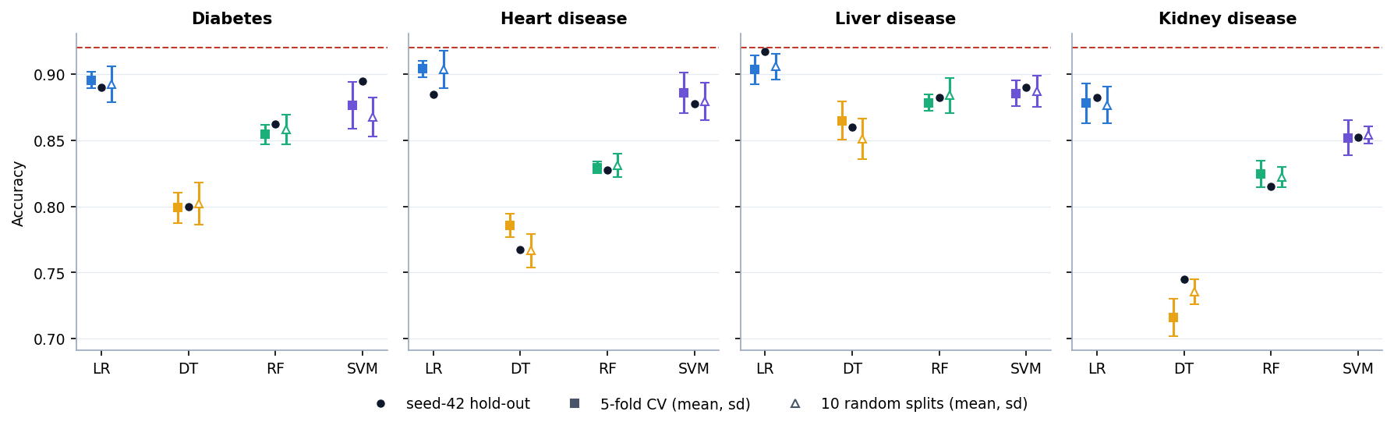
Figure 1: Accuracy on the single hold-out split, in 5-fold cross-validation and on ten random splits (error bars: one standard deviation; dashed line: 92% noise ceiling)
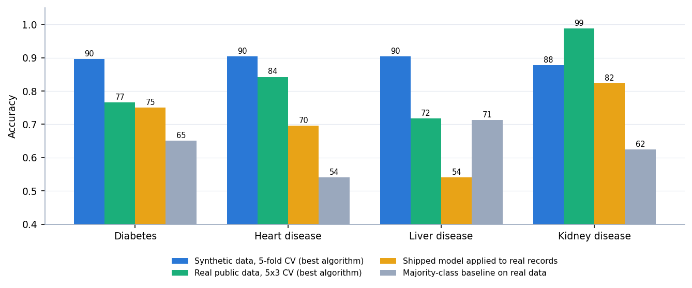
Figure 2: Accuracy on synthetic data versus real public data, and of the shipped models on real records

4. WHAT WAS NOT MEASURED
The following were not measured, and no number for them appears in this work:
• Performance on real patients, on an external data set, or in a prospective setting.
• Probability calibration (no reliability curve or Brier score was computed).
• Nested cross-validation or a tuned model; the effect of a hyper-parameter search.
• Fairness or subgroup performance by sex or age.
• Agreement of the permutation importance with SHAP or with clinical knowledge beyond the generator's own rule.
• Usability with clinicians or patients, accessibility audits, and behaviour in browsers other than Chrome.
• Security, load beyond four concurrent clients, or latency on a deployed server.
• The effect of recommendations on health outcomes (none are produced).

